INDIAN SCHOOL AL WADI AL KABIR
DEPARTMENT OF SOCIAL SCIENCE
Academic Year (2023-24)

Class VI From Hunting- Gathering Food

Model Making (Graded Activity)

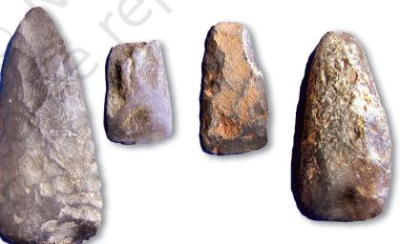
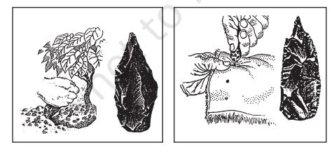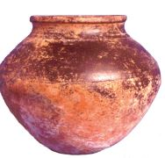

General instructions:-
1) Make any one of the models of tools or pot of Stone Age period given above.
2) Materials that can be used for the model are chart paper, clay, cardboard, best out of the waste material, foam board, aluminum foil paper etc.
(Use any material from the above or any other material of your choice)
3) Label your Model with your name, class & section.
4) Present your model in a creative way.

Date Submission: 10-08-2023

